24K-0559
BAZIL UDDIN KHAN
LAB 12

Task1).
Code:
#include <iostream>
using namespace std;
void Product(int a, int b, int c);
void Product(int num1, int num2, int num3)
{
int result = 0;

__asm
{
mov eax, num1
mov ebx, num2
mul ebx
mov edx, num3

mul edx
mov result,eax
}
cout << " Product of 3 integers is : " << result << endl;
}
int main()
{
int num1;
cout << "Enter Num1 \n";
cin >> num1;
int num2;
cout << "Enter Num2 \n";
cin >> num2;
int num3;
cout << "Enter Num3 \n";
cin >> num3;

Product(num1, num2, num3);

return 0;
}

Output:
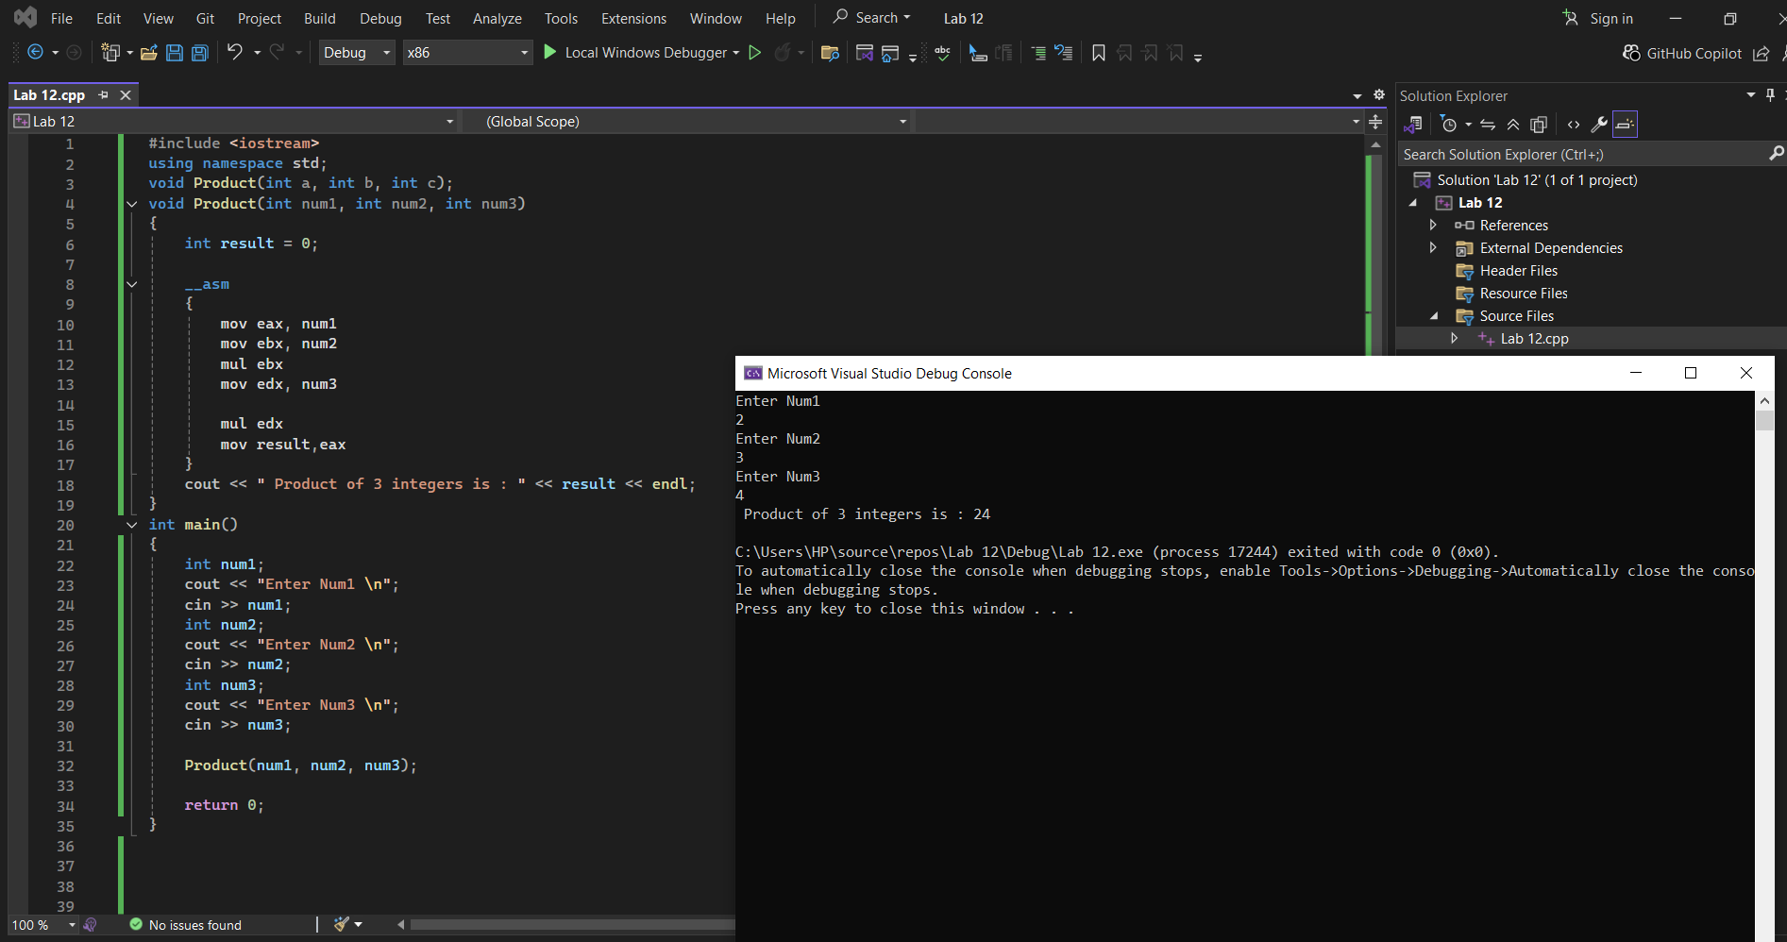

Task2).
Code:
#include <iostream>
using namespace std;
int Gcd(int a, int b);
int Gcd(int a, int b)
{
__asm
{
mov eax, a
mov ebx, b
l1:

cmp ebx,0
je exitloop

cdq
idiv ebx

mov eax,ebx
mov ebx,edx
jmp L1

exitloop:
mov [a],eax

}
return a;
}

int main()
{
int num1;
cout << "Enter Num1 \n";
cin >> num1;
int num2;
cout << "Enter Num2 \n";
cin >> num2;
cout << "Gcd = " << Gcd(num1, num2) << endl;
return 0;
}
Output:
